Experiment-3
Create a simple cloud software application for Car Booking Reservation System using any Cloud Service Provider to demonstrate SaaS
Aim:
To develop a simple cloud-based Car Booking Reservation System using a Cloud Service Provider to demonstrate SaaS.
Procedure:
- Create an account in Zoho Creator.
- Create an application named Car Booking Reservation System.
- Create a booking form.
- Add fields such as Customer Name, Phone, Email, Car Model, Pickup Location, Drop Location, Number of Days, Rent per Day, and Total Amount.
- Calculate the total booking amount automatically.
- Store booking information in the cloud.
- Publish the application for users.
IMPLIMENTATION:
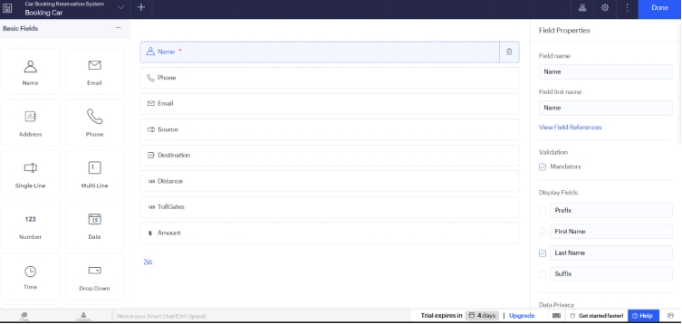
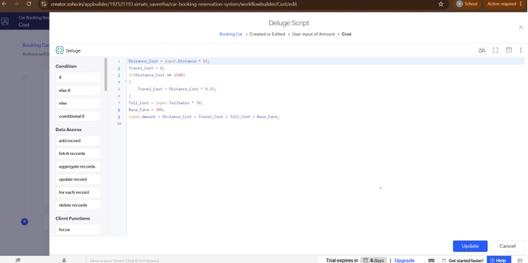
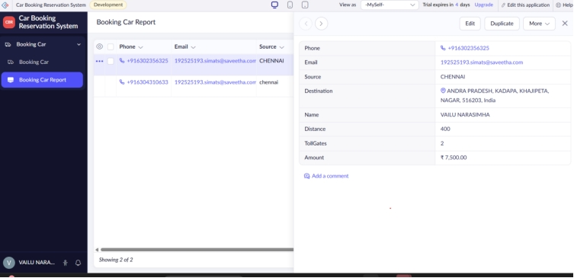
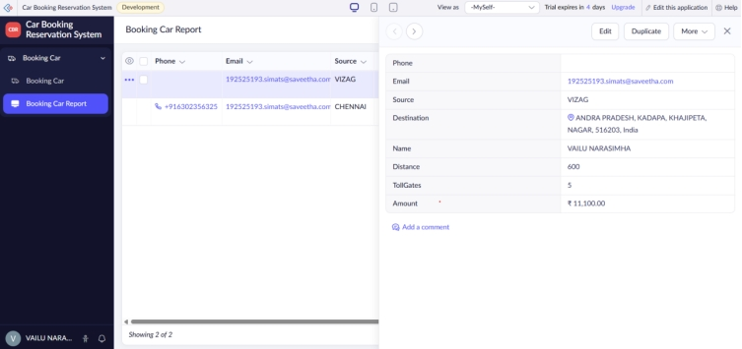
Result:
A cloud-based Car Booking Reservation System was successfully developed. Users can enter booking details, calculate the total amount, and reserve a car online.

